**Project Name:aha**

**Developed By :P Hari Krishnam Raju**

**R Shiva Kumar**

**Login page:**

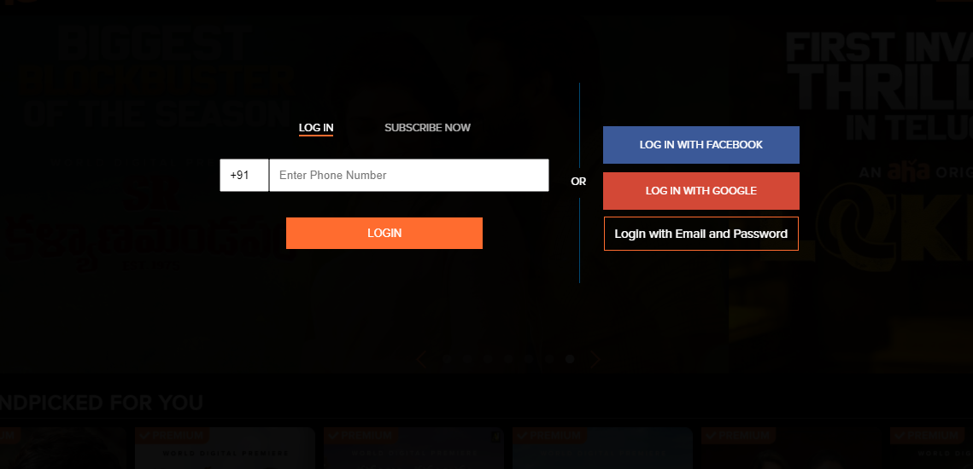



**Home Page:**

In home page we are adding one more extra option as Music page and the music page should be like this as shown in below

**Music page:**

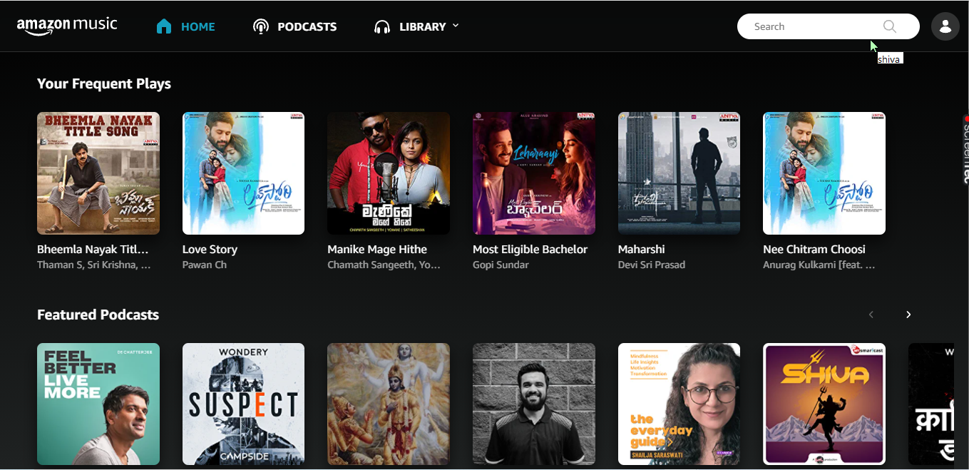

**Goals**

* Login page
* Subscription page
* Payment page
* Streaming page
* Login and logout page
* music page

**History:**

**Front-End:**

1. Html

2. Css

3. Bootstrap

4. React

**Dynamic:**

1. JavaScript

2. Ci/cd with AWS

3. Login and Logout (oauth and jwt)

**Database:**

1. Mongo db

2. Json Data

**Code compilers**:

1. Visual studio code

2. Git bash

3. Git hub

4. node js